ASSIGNMENT-2
Quality Control Analysis using Discrete Probability Distributions — AIML Laboratory
Step 1-3. Open Binomial Module, set n = 20 and p = 0.05. Calculate mean, variance, and probability of exactly 2 defects.
Answer:
1. Summary Statistics (n = 20, p = 0.05):
• Mean (μ) = n × p = 20 × 0.05 = 1.00 defect
• Variance (σ²) = n × p × (1 - p) = 20 × 0.05 × 0.95 = 0.95
• Standard Deviation (σ) = √(0.95) = 0.9747
• Second Moment E[X²] = σ² + μ² = 0.95 + 1.00 = 1.95
• Skewness = (1 - 2p) / σ = (1 - 0.10) / 0.9747 = 0.9234
2. Probability Calculation for Exactly 2 Defects (k = 2):
Formula: P(X = k) = C(n, k) · p^k · (1-p)^(n-k)
P(X = 2) = C(20, 2) · (0.05)² · (0.95)¹⁸
C(20, 2) = (20 × 19) / 2 = 190
P(X = 2) = 190 · 0.0025 · 0.397214 = 0.188677 (18.87%)
Interpretation: In a sample batch of 20 products, there is an 18.87% probability of finding exactly 2 defective items under standard manufacturing conditions.
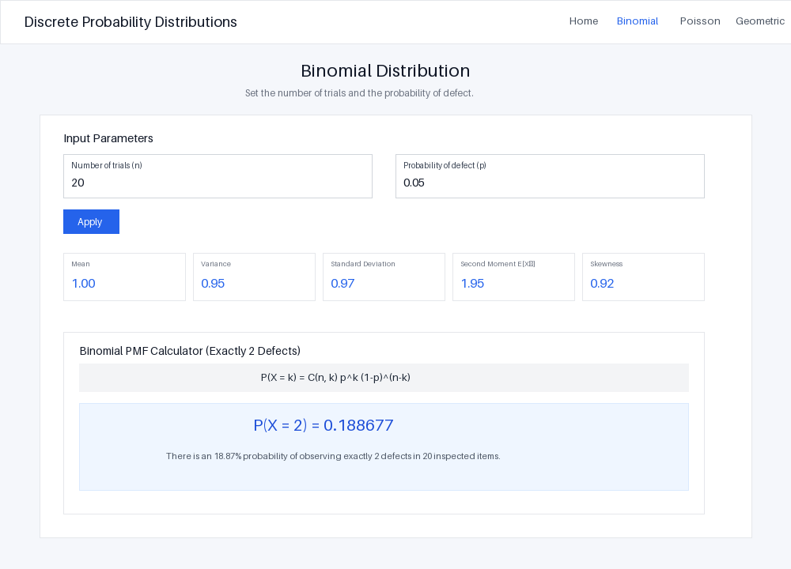
Figure 1: Binomial Distribution Module (n = 20, p = 0.05, k = 2)
Step 4-5. View the PMF graph and change p from 0.05 to 0.10. Observe how the distribution shifts toward larger defect counts.
Answer:
Comparative Analysis when p Increases from 0.05 to 0.10:
• Mean Shift: Expected defects double from μ = 1.00 defect to μ = 2.00 defects.
• Variance Expansion: Variance increases from σ² = 0.95 to σ² = 1.80, indicating greater uncertainty and spread in batch defect counts.
• PMF Graph Shift: The peak (mode) of the bar chart shifts rightward from k = 1 to k = 2. Higher defect counts (e.g., k ≥ 3) become significantly more probable, while zero defect batches drop from 35.85% down to 12.16%.
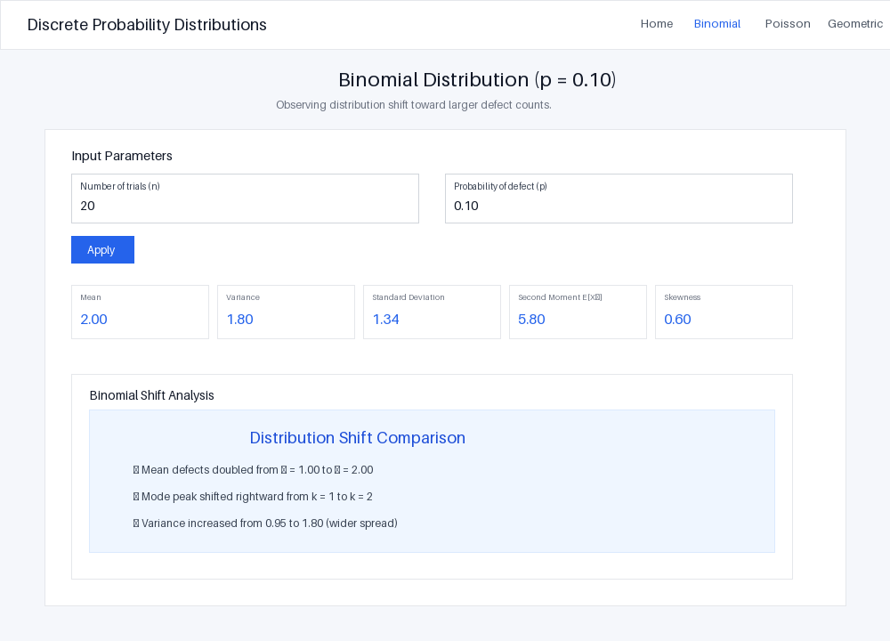
Figure 2: Binomial Distribution Shift (n = 20, p = 0.10)
Step 6. Open Poisson module, enter λ = 5 for 100 inspected products. Compare Poisson probabilities with Binomial results.
Answer:
1. Poisson Model Parameters (λ = 5.00):
• Mean (μ) = λ = 5.00 defects per 100 products
• Variance (σ²) = λ = 5.00
• Standard Deviation (σ) = √5 = 2.2361
2. Mathematical Comparison (Poisson vs Binomial with n = 100, p = 0.05):
• Expected Value: Both models share the exact same mean μ = n × p = 100 × 0.05 = 5.00 defects.
• Exact 2 Defects P(X = 2):
- Poisson: P(X = 2) = (e⁻⁵ · 5²) / 2! = (0.006738 × 25) / 2 = 0.084224 (8.42%)
- Binomial: P(X = 2) = C(100, 2) · (0.05)² · (0.95)⁹⁸ = 4950 × 0.0025 × 0.006560 = 0.081180 (8.12%)
- Absolute Difference: 0.003044 (< 0.3% difference)
Conclusion: The Poisson distribution provides an excellent limiting approximation for the Binomial model when sample size n is large (n = 100) and defect probability p is small (p = 0.05).
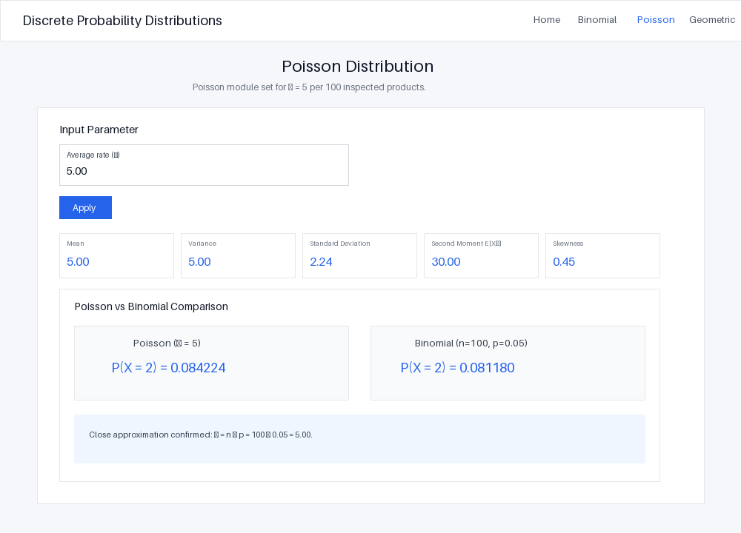
Figure 3: Poisson Distribution Module (λ = 5.00)
Step 7. Open Geometric module, enter p = 0.05. Examine the probability of detecting the first defect on different inspection attempts.
Answer:
1. Geometric Parameters & Key Statistics (p = 0.05):
• Mean / Expected Attempt E[X] = 1 / p = 1 / 0.05 = 20 items
• Variance (σ²) = (1 - p) / p² = 0.95 / 0.0025 = 380.00
• Standard Deviation (σ) = √(380) = 19.49 items
2. Probability of First Defect on Specific Inspection Attempts:
Formula: P(X = k) = (1-p)^(k-1) · p
• 1st Attempt (k = 1): P(X = 1) = (0.95)⁰ · 0.05 = 0.050000 (5.00%)
• 2nd Attempt (k = 2): P(X = 2) = (0.95)¹ · 0.05 = 0.047500 (4.75%)
• 5th Attempt (k = 5): P(X = 5) = (0.95)⁴ · 0.05 = 0.040725 (4.07%)
• 10th Attempt (k = 10): P(X = 10) = (0.95)⁹ · 0.05 = 0.031512 (3.15%)
3. Cumulative Probability within First 20 Items: P(X ≤ 20) = 1 - (0.95)²⁰ = 0.641514 (64.15%).
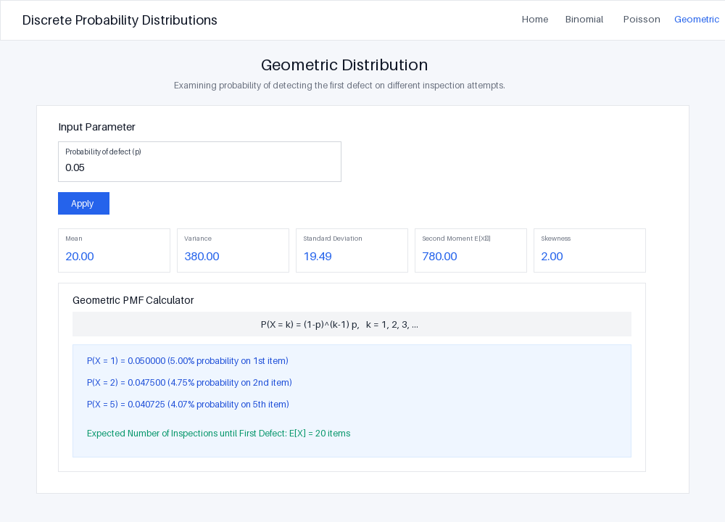
Figure 4: Geometric Distribution Module (p = 0.05)
Step 8. Write down numerical results, graph observations, and an inference about the quality-control process.
Answer:
1. Summary Table of Numerical Results:
Experiment Module | Parameters | Expected Mean (μ) | Key Probability Result
Binomial Baseline | n = 20, p = 0.05 | 1.00 defect | P(X = 2) = 18.87%
Binomial Shift | n = 20, p = 0.10 | 2.00 defects | P(X ≥ 3) = 32.31%
Poisson Approximation | λ = 5 per 100 items | 5.00 defects | P(X = 2) = 8.42%
Geometric Inspection | p = 0.05 | 20 items to 1st defect | P(X ≤ 20) = 64.15%
Binomial Large Batch | n = 100, p = 0.05 | 5.00 defects | P(X = 2) = 8.12%
2. Graph Observations:
• Right-Skewness in Low Defect Rates: At p = 0.05, both Binomial and Geometric distributions exhibit right-skewness. Most probability mass concentrates at lower defect counts.
• Sensitivity to Parameter Shifts: Doubling p from 0.05 to 0.10 flattens the curve and shifts the peak rightward, significantly inflating tail probabilities.
3. Quality-Control Process Inferences & Engineering Decisions:
• Sampling Inspection Strategy (Geometric): Quality inspectors can expect to test an average of 20 items before finding a defect when the baseline defect rate is 5%. If defects appear within 5 or fewer items repeatedly, it serves as an early statistical warning of process deterioration.
• Setting Control Chart Thresholds (Binomial/Poisson): In batches of 20 items at p = 0.05, finding 0 or 1 defect accounts for 73.58% of outcomes. Batches with 4 or more defects occur less than 1.6% of the time. Therefore, an upper control limit (UCL) of 4 defects should trigger an immediate production line pause and machine re-calibration.
• High-Volume Quality Monitoring Efficiency (Poisson): For continuous assembly lines inspecting large batches (n = 100), the Poisson model (λ = 5) provides an computationally efficient, highly accurate model for real-time defect tracking without complex combination calculations.

